**INTRODUCTION:-**

Cosmetics are commercially available products that are used to improve the appearance of the skin by action of cleansing, beautifying, promoting attractiveness. From the ancient time, different herbs are used for cleaning, beautifying and to manage them. Face skin is the major part of the body, which indicates the health of an individual. It consists of materials such as amino acids, lipids and carbohydrates etc. So that a balanced nutrition is required for the skin to keep it clear glossy and healthy.In ayurveda, the herbal paste is called as “mukha lepa” used for as a facial therapy. This herbal paste smeared on face to treat acne, pimple, scars, marks and pigments.

Face pack is the smooth powder which is used for facial application. These preparations are applied on the face in the form of liquid or pastes and allowed to dry and set to form film giving tightening, strengthening and cleansing effect to the skin.5 They are usually left on the skin for ten to twenty five minutes to allow all the water to evaporate, the resulting film thus contracts and hardens and can easily be removed. The warmth and tightening effect produced by application of face pack produces the stimulating sensation of a rejuvenated face, while the colloidal and adsorption clays used in these preparations remove the dirt and grease from the skin of the face. When the applied face pack is eventually removed skin debris and deposited dirt gets removed with it.

Face packs are basically additives delivering some additional benefits. Different types of herbal face packs are used for different types of skin. Herbal face packs are helps to reduce wrinkles, pimples, acne and dark circles. Also increase the fairness and smoothness of skin. It also helps someone to boost their confidence. Ayurveda is the most useful and successful means for achieving this purpose.

These packs are available in various types and forms and broadly classified into the following categories:

1. Plastic masks: Wax based, latex based, or vinyl based

2. Hydrocolloid masks: Gel masks (ready to use)

3. Argillaceous masks: Clay based or earth based (ready to use or dry powder)

Present research article deals with the formulation and evaluation of cosmetic herbal face pack for glowing skin at home by using natural materials Multani mitti, turmeric, *Aloe vera*, sandalwood, orange peel, neem and nutmeg.

**MATERIALS AND METHODS:-**

All the natural materials used in the present study i.e., multani mitti, turmeric, *Aloe vera*, sandalwood, orange peel, neem and nutmeg were purchased from local market (Dgadu Teli Chandwadkar, Nashik), in a form of dried powder and were authenticated at Botany department of KTHM College, Nashik. The details of the plant material used for the formulation of face pack are mentioned below;

**Multani Mitti (Calcium bentonite):-**

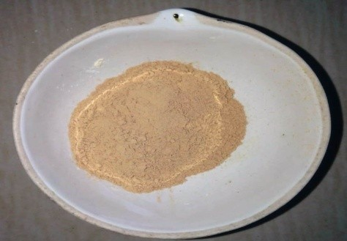

Multani mitti helps skin by different ways like diminishing pore sizes, removing blackheads and whiteheads fading freckles, soothing sunburns, cleansing skin, improving blood circulation, complexion, reducing acne and blemishes and gives a glowing effect to a skin as they contain healthy nutrients. Multani mitti is rich magnesium chloride.

**Turmeric (***Curuma longa***):-**

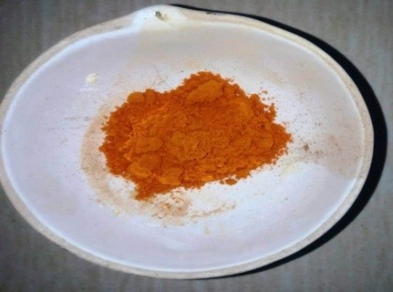 Turmeric is mainly used to rejuvenate the skin. It delays the signs of aging like wrinkles and also possesses other properties like antibacterial, antiseptic and anti-inflammatory. It is best source of blood purifier. It is effective in treatment of acne due to its antiseptic and antibacterial properties that fight pimples and breakouts to provide a youthful glow to your skin. It also reduces the oil secretion by the sebaceous glands.

**Aloe Vera (***Aloe barbadensis***):-**

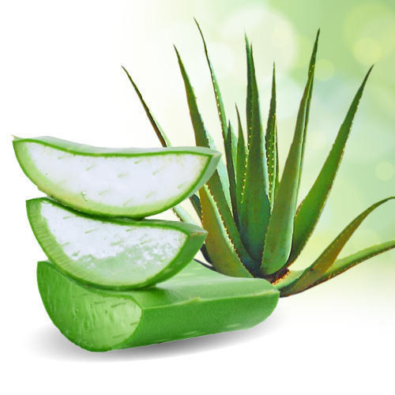 Aloe vera is a great moisturizer intended for a skin. Aloe vera rejuvenates skin, hydrates this and keeps skin layer looking fresh all the time. Aloe vera has anti-microbial property rendering it ideal to deal with acne and pimples. Aloe vera powder contains several nutrients like glycerin, sodium palmate, sodium carbonate, sodium palm kemelate, sorbitol, etc.

**Sandal wood (***Santalum alba***):-**

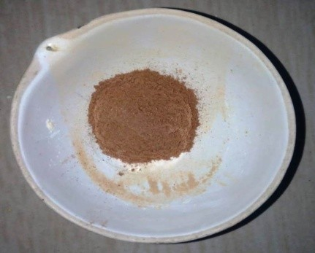 Sandal wood has an anti-tanning and anti-aging property. It also helps skin in many ways like toning effect, emollient, antibacterial properties, cooling astringent property, soothing and healing property.

**Orange peel (***Citrus reticulate***):-**

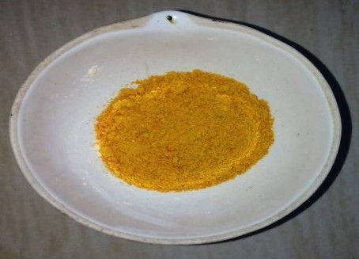 Orange is a citrus fruit which contains different nutritional source such as vitamin C, calcium, potassium and magnesium. It prevents the skin from free radical damage, skin hydration and oxidative stress. Also it has instant glow property, prevent acne, blemishes, wrinkles and aging.

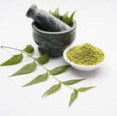**Neem (***Azadirachta indica***):-**

Neem is anti-inflammatory, antiseptic and highly beneficial for oily and acne prone skin 14. An anti-acne effect is due to anti-microbial, anti-inflammatory and anti-oxidant activities of different chemical constituents.

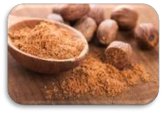**Nutmeg (***Myristica fragrans***):-**

Nutmeg is widely used for its analgesic, anti-inflammatory, antiseptic and anti-bacterial property14. It helps in reducing wrinkles, fine lines and other signs of aging. It also helps in reducing acne scars and to make them less noticeable.

**METHODS OF PREPARATION:-**

Four different formulations were prepared with varying concentrations of all ingredients named as F1 to F4. Concentration of each ingredient was mentioned in Table 1. The accurate quantity ingredients were weighed and ground into fine powder by using sieve #120. Then the all ingredients were mixed geometrically by serial dilution method for uniform mixing. Then the prepared face pack was packed into a self-sealable polyethylene bag, labeled and used for further studies.

**METHODS OF PREPARATION:**

The accurate quantity ingredients were weighed and ground into fine powder by using sieve #120. Then the face pack was packed into a self-sealable polyethylene bag, labeled and used for further studies.

**PROCEDURE OF FACE PACK APPLICATION:-**

Take prepared face pack powder in a bowl as per the requirement and add rose water to mix. Mix well and apply over the facial skin. Cover the acne and blemishes spots too. Kept as it is for complete drying for 20 to 25 min and then wash with cold water.

**:Formulation of Face Pack:**

|  |  |  |  |  |  |  |
| --- | --- | --- | --- | --- | --- | --- |
| **Sl. No** | **Name Of**  **Ingredients** | **Scientific**  **Name** | **Quantity Of Sample For 100g** | | | |
|  | | | **F1** | **F2** | **F3** | **F4** |
| **1.** | Multani Mitti | Calcium Bentonite | 25 | 30 | 35 | 15 |
| **2.** | Turmeric | *Curuma longa* | 20 | 05 | 10 | 20 |
| **3.** | Aloe Vera | *Aloe barbadensis* | 10 | 15 | 10 | 20 |
| **4.** | Sandal wood | *Santalum alba* | 25 | 25 | 20 | 25 |
| **5.** | Orange peel | *Citrus reticulate* | 10 | 12 | 06 | 05 |
| **6.** | Neem | *Azadirachta indica* | 03 | 08 | 15 | 10 |
| **7.** | Nutmeg | *Myristica fragrans* | 07 | 05 | 04 | 05 |

**METHODS OF EVALUATION :**

Following evaluation parameters were performed to ensure superiority of prepared face pack.

1. **Organoleptic Evaluation:**

The organoleptic parameters include its nature, color, odor, feel and consistency which were evaluated manually for its physical properties.

1. **Physical Evaluation:**

The particle size was tested by microscopy method. The flow property of the dried powder of combined form was evaluated by performing Angle of Repose by funnel method, bulk density and tapped density by Tapping Method.

1. **Physicochemical Evaluation:**

Ash content was performed using incinerator, pH was found by using pH meter and loss on drying was also performed.

1. **Irritancy Test:**

Mark an area (1sq.cm) on the left-hand dorsal surface. Definite quantities of prepared face packs were applied to the specified area and time was noted. Irritancy, erythema, edema, was checked if any for regular intervals up to 24 hrs and reported.

1. **Stability Studies:**

Stability testing of prepared formulation was conducted for formulation F2 by storing at different temperature conditions for the period of one month. The packed glass vials of formulation stored at different temperature conditions viz.., Room temperature, 35ºC and 40ºC and were evaluated for physical parameters like Color, Odour, pH, Consistency and feel.

1. **Shinoda Test:**

To the ethanolic extract, a few drops of concentrated hydrochloric acid (HCl) were added. Then the magnesium turnings were put into the solution and observed for appearance of pink red colour.

1. **Morphological Evaluation:**

Herbal face pack was evaluated for morphological parameters showed in the table. The colour of formulation was pale yellow. The odour of prepared formulations was pleasant and good acceptable which is desirable to cosmetic formulations. Texture and smoothness was acceptable as per requirement of cosmetic formulations.

1. **Rheological Evaluation:**

It gives an overall idea about the visco elastic flow behavior of the product. Physical parameters like angle of repose, tapped density, bulk density, Hausner’s ratio and Carr’s index were observed and calculated for the formulation.

1. **Angle of repose:**

The angle of repose or critical angle of repose, of a granular material is the steepest angle of descent or dip relative to the horizontal plane to which a material can be piled without stumping. It’s important for the design of processing, storage and conveying systems of particulate materials. It is also useful to quantify the flow properties of powder because it

influences cohesion among the different particles. The fixed funnel cone method employs the calculation of height (H) above a paper that is placed on a horizontal surface. The formulated pack was carefully poured through the funnel till the peak of the conical heap just touched the tip of the funnel. Here ‘R’ denotes the radius of the conical heap.

The equation for calculating angle of repose(a) is,

**{a=** 𝐭𝐚𝐧−𝟏𝑯𝑹}

**(II) Tapped Density:**

The tapped density is an increased bulk density attained after mechanically tapping a graduated measuring cylinder containing powder sample. The tap density of a powder can be used to predict both flow properties and its compressibility. The volume of packaging can be determined in a graduated cylinder. 25gms of weighed formulation powder was taken and slowly added to the cylinder with the aid of a funnel. The initial volume was observed firstly and the sample was then tapped until no further volume reduction occurred. The value obtained after tapping was noted. The equation for calculating the tapped density is, **Tapped density =** 𝑾𝒆𝒊𝒈𝒉𝒕 (𝒈)**/**𝑻𝒂𝒑𝒑𝒆𝒅 𝒗𝒐𝒍𝒖𝒎𝒆(𝒎𝒍)

**RESULT AND DISCUSSION:**

1. **Organoleptic Evaluation:**

Face pack was prepared and evaluated for Organolepticparameters showed in the table below. The flow property parameter showed free flowing properties. The colour of formulation was slight yellow. The odor of prepared formulations was good acceptable which is desirable as cosmetic formulations. Texture and Smoothness was good acceptable which is desirable as cosmetic formulations.

|  |  |  |  |  |  |
| --- | --- | --- | --- | --- | --- |
| **Sl. No** | **Parameters** | **Observations** | | | |
|  | | F1 | F2 | F3 | F4 |
| 1. | Appearance | Powder  (Free Flowing) | Powder  (Free Flowing) | Powder  (Free Flowing) | Powder  (Free Flowing) |
| 2. | Colour | Slight Yellow | Slight Yellow | Greenish yellow | slight yellow |
| 3. | Odour | Slight | Slight | Slight | Slight |
| 4. | Texture | Fine | Fine | Fine | Fine |
| 5. | Smoothness | Smooth | Smooth | Smooth | Smooth |

**(b) Physical and Physicochemical Evaluation:**

The particle size of formulations were in the range of 26.4±5.44μm. The pH of formulation lied near to neutral. The ash content and moisture content was within limit.

|  |  |  |  |  |  |
| --- | --- | --- | --- | --- | --- |
| Sl. No | Parameters | Observation | | | |
|  | | F1 | F2 | F3 | F4 |
| 1. | Particle size (μm) | 26.4 ± 5.44 | 22.5 ± 2.85 | 24.8 ± 4.36 | 25.2 ± 5.21 |
| 2. | Ash content | 93 ± 0.732 | 87 ± 0.859 | 92 ± 0.556 | 95 ± 0.462 |
| 3. | Ph | 7.66 ± 0.13 | 6.65 ± 0.1 | 6.79 ± 0.16 | 6.88 ± 0.1 |
| 4. | Loss on Drying | 3.33 | 3 | 4 | 3.67 |

**(c) Irritancy Test:**

The results of irritancy test were shown in Table 4. The formulation showed no irritation, redness, edema and Inflammation during irritancy studies. This formulation is safe to use for skin.

|  |  |  |  |  |  |  |
| --- | --- | --- | --- | --- | --- | --- |
| Sl. No | Evaluation | Formulations | | | | Observation |
|  | | F1 | F2 | F3 | F4 |  |
| 1. | Irritant | + | Nil | + | + | No Irritation |
| 2. | Erythema | Nil | Nil | Nil | Nil | No Irritation |
| 3. | Edema | Nil | Nil | Nil | Nil | No Irritation |

**(d) Stability studies:**

The stability studies showed a slight change in pH of formulation which was stored at 400C and no changes were observed at room temperature and at 350C. There was no change in color and odour at other mentioned conditions of stability. Texture of the formulation remained fine at all temperature conditions & smoothness was also retained, which were shown in table below.

|  |  |  |  |  |
| --- | --- | --- | --- | --- |
| Sl.No | Parameters | Observations (Formulation F2) | | |
|  | | **Room Temperature** | **35±0.5ºC** | **40±0.5ºC** |
| 1. | Colour | No change | No change | No change |
| 2. | Odour | No change | No change | Slightly Change |
| 3. | pH | 6.65±0.17 | 6.65±0.11 | 6.72±0.21 |
| 4. | Texture | Fine | Fine | Fine |
| 5. | Smoothness | Smooth | Smooth | Smooth |

**(e) Shinoda test:**

Flavonoids are present.

**CONCLUSION:**

In the present scenario, people need cure for various skin problems without side effects. Herbal ingredients opened the way to formulate cosmetics without any harmful effect. Herbal face packs are considered as sustaining and productive way to advance the appearance of skin. Thus, in the present work, it is a very good attempt to formulate the herbal face pack containing naturally available ingredients like multani mitti, turmeric, aloe vera, sandalwood, orange peel, neem and nutmeg.

Natural remedies are more acceptable in the belief that they are safer with fewer side effects than the synthetic ones. Herbal formulations have growing demand in the world market. Herbal face packs are used to stimulate blood circulation,rejuvenate the muscles and help to maintain the elasticity of the skin and remove dirt from skin pores. It is our good attempt to formulate the herbal face pack containing natural herbal ingredients such as multani mitti, turmeric, sandal wood, saffron, milk powder, rice flour, orange peel and banana peel. After evaluation, we found good properties for the face packs, free from skin irritation and maintained its consistency even after stability storage conditions. It has been revealed that herbal face pack have enough potential to give efficient glowing effect on skin. The overall study is useful to substantiate product claims due its useful benefits on the human beings.